**Short Report**

**ORGANISATION NAME**

Day Month, Year

**About i-Hub**

Project ##

Project Title

The Innovation Hub for Affordable Heating and Cooling (i-Hub) is an initiative led by the Australian Institute of Refrigeration, Air Conditioning and Heating (AIRAH) in conjunction with CSIRO, Queensland University of Technology (QUT), the University of Melbourne and the University of Wollongong and supported by Australian Renewable Energy Agency (ARENA) to facilitate the heating, ventilation, air conditioning and refrigeration (HVAC&R) industry’s transition to a low emissions future, stimulate jobs growth, and showcase HVAC&R innovation in buildings.

The objective of i-Hub is to support the broader HVAC&R industry with knowledge dissemination, skills-development and capacity-building. By facilitating a collaborative approach to innovation, i-Hub brings together leading universities, researchers, consultants, building owners and equipment manufacturers to create a connected research and development community in Australia.

|  |
| --- |
| **This Project received funding from ARENA as part of ARENA's Advancing Renewables Program. The views expressed herein are not necessarily the views of the Australian Government, and the Australian Government does not accept responsibility for any information or advice contained herein.** |

|  |  |  |  |  |
| --- | --- | --- | --- | --- |
|  |  | |  | **Primary Project Partner** |
|  | |  |  | [logo] |

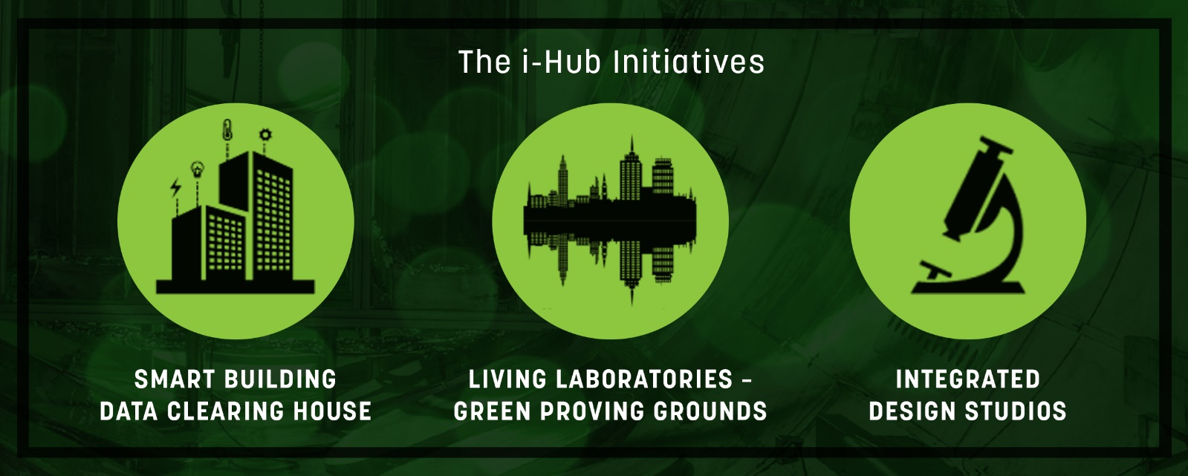

**Short Report Template**

The details provided on your sub-project in this Short Report will be displayed on the corresponding sub-project page of the i-Hub website (<http://ihub.org.au>)

i-Hub input

|  |  |  |  |  |  |  |
| --- | --- | --- | --- | --- | --- | --- |
| Project title |  | | | | | |
| Project number |  | | Project location | |  | |
| Lead partner |  | | | | | |
| Project partners |  | | | | | |
| Project participants |  | | | | | |
| Start date (MM/YYY) |  | | End date (MM/YYYY) |  | | |
| ARENA / i-Hub funding | **$** |  | Total Project cost | **$** | |  |
| Image / video? |  | | | | | |
| Graphics / multimedia? |  | | | | | |

Recipient input

|  |  |
| --- | --- |
| **About your Project** |  |
| *Please provide a short summary of your Project (max. 100 words)* |
|  | |
| **Need** |  |
| *Provide a brief description of the issues your Project aims to solve. This can be issues faced now or ones expected to emerge if no action is taken (max. 100 words)* |
|  | |
| **Action** |  |
| *Provide a summary of the activity your organisation is undertaking in order to solve the issues listed above (max. 100 words)* |
|  | |
| **Outcome** |  |
| *Provide a brief overview of what your Project is expected to achieve (max. 100 words)* |
|  | |
| **Additional impact (optional)** |  |
| *Describe any additional impact your Project is expected to achieve, e.g. community engagement initiatives, number of jobs, knowledge sharing initiatives (max. 50 words)* |
|  | |