**Lesson Learnt Report**

**ORGANISATION NAME**

Day Month, Year

**About i-Hub**

Project ##

Project Title

The Innovation Hub for Affordable Heating and Cooling (i-Hub) is an initiative led by the Australian Institute of Refrigeration, Air Conditioning and Heating (AIRAH) in conjunction with CSIRO, Queensland University of Technology (QUT), the University of Melbourne and the University of Wollongong and supported by Australian Renewable Energy Agency (ARENA) to facilitate the heating, ventilation, air conditioning and refrigeration (HVAC&R) industry’s transition to a low emissions future, stimulate jobs growth, and showcase HVAC&R innovation in buildings.

The objective of i-Hub is to support the broader HVAC&R industry with knowledge dissemination, skills-development and capacity-building. By facilitating a collaborative approach to innovation, i-Hub brings together leading universities, researchers, consultants, building owners and equipment manufacturers to create a connected research and development community in Australia.

|  |
| --- |
| **This Project received funding from ARENA as part of ARENA's Advancing Renewables Program. The views expressed herein are not necessarily the views of the Australian Government, and the Australian Government does not accept responsibility for any information or advice contained herein.** |

|  |  |  |  |  |
| --- | --- | --- | --- | --- |
|  |  | |  | **Primary Project Partner** |
|  | |  |  | [logo] |

The information or advice contained in this document is intended for use only by persons who have had adequate technical training in the field to which the Report relates. The information or advice should be verified before it is put to use by any person. Reasonable efforts have been taken to ensure that the information or advice is accurate, reliable and accords with current standards as at the date of publication. To maximum extent permitted by law, the Australian Institute of Refrigeration, Air Conditioning and Heating Inc. (AIRAH), its officers, employees and agents:

a) disclaim all responsibility and all liability (including without limitation, liability in negligence) for all expenses, losses, damages and costs, whether direct, indirect, consequential or special you might incur as a result of the information in this publication being inaccurate or incomplete in any way, and for any reason; and

b) exclude any warranty, condition, guarantee, description or representation in relation to this publication, whether express or implied.

In all cases, the user should be able to establish the accuracy, currency and applicability of the information or advice in relation to any specific circumstances and must rely on his or her professional judgment at all times.

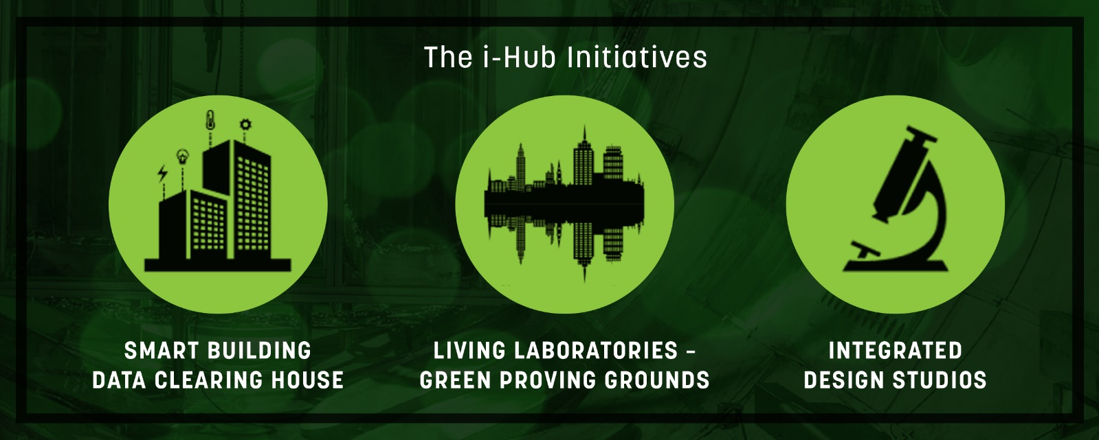

**i-Hub Lessons Learnt Report**

**Guidance notes for completion of the Lessons Learnt Report:**

* This report is intended to be made public.
* Please use plain English, minimise jargon or unnecessary technical terms.
* Please use your organisation’s branding for the report.
* The report should meet your organisation’s publishing standards.
* Please use one template per each major lesson learnt and include as many as are relevant for your sub-Project. If what you learnt is more technical, this is the section to include technical information.
* The content of these Lessons Learnt Reports can be compiled (and updated, where necessary) for inclusion in the (public) Project Knowledge Sharing Report, for submission at the completion of your sub-Project.

|  |  |  |  |
| --- | --- | --- | --- |
| Lead organisation |  | | |
| Sub-Project number |  | | |
| Sub-Project commencement date |  | Completion date |  |
| Report date |  | | |
| Contact name |  | | |
| Position in organisation |  | | |
| Phone |  | Email |  |

**Lessons learnt**

|  |  |  |  |  |  |  |
| --- | --- | --- | --- | --- | --- | --- |
| Lesson learnt #1 | (Insert topic) | | | | | |
|  | | | | | | |
| **Category** |  | | | | | |
| *Choose from:* | *Technical* | *Commercial* | *Social* | *Regulatory* | *Logistical* | *Other (specify)* |
|  | | | | | | |
| Describe what you learnt about this aspect of the Project. | | | | | | |
|  | | | | | | |
| Please describe what you would do differently next time and how this would help. What are the implications for future Projects? | | | | | | |
|  | | | | | | |
| If your Project learnings have identified any knowledge gaps that need to be filled, please state it below. | | | | | | |
|  | | | | | | |
| Please include any other information you feel is relevant or helpful in sharing the knowledge you learnt through this stage of the Project. This may be qualitative or quantitative and may include a graph, chart, infographic or table as appropriate. | | | | | | |
|  | | | | | | |

|  |  |  |  |  |  |  |
| --- | --- | --- | --- | --- | --- | --- |
| Lesson learnt #2 | (Insert topic) | | | | | |
|  | | | | | | |
| **Category** |  | | | | | |
| *Choose from:* | *Technical* | *Commercial* | *Social* | *Regulatory* | *Logistical* | *Other (specify)* |
|  | | | | | | |
| Describe what you learnt about this aspect of the Project. | | | | | | |
|  | | | | | | |
| Please describe what you would do differently next time and how this would help. What are the implications for future Projects? | | | | | | |
|  | | | | | | |
| If your Project learnings have identified any knowledge gaps that need to be filled, please state it below. | | | | | | |
|  | | | | | | |
| Please include any other information you feel is relevant or helpful in sharing the knowledge you learnt through this stage of the Project. This may be qualitative or quantitative and may include a graph, chart, infographic or table as appropriate. | | | | | | |
|  | | | | | | |

|  |  |  |  |  |  |  |
| --- | --- | --- | --- | --- | --- | --- |
| Lesson learnt #3 | (Insert topic) | | | | | |
|  | | | | | | |
| **Category** |  | | | | | |
| *Choose from:* | *Technical* | *Commercial* | *Social* | *Regulatory* | *Logistical* | *Other (specify)* |
|  | | | | | | |
| Describe what you learnt about this aspect of the Project. | | | | | | |
|  | | | | | | |
| Please describe what you would do differently next time and how this would help. What are the implications for future Projects? | | | | | | |
|  | | | | | | |
| If your Project learnings have identified any knowledge gaps that need to be filled, please state it below. | | | | | | |
|  | | | | | | |
| Please include any other information you feel is relevant or helpful in sharing the knowledge you learnt through this stage of the Project. This may be qualitative or quantitative and may include a graph, chart, infographic or table as appropriate. | | | | | | |
|  | | | | | | |