**Project Expression of Interest Form**

**ORGANISATION NAME**

Day Month, Year

**About i-Hub**

Project Title

The Innovation Hub for Affordable Heating and Cooling (i-Hub) is an initiative led by the Australian Institute of Refrigeration, Air Conditioning and Heating (AIRAH) in conjunction with CSIRO, Queensland University of Technology (QUT), the University of Melbourne and the University of Wollongong and supported by Australian Renewable Energy Agency (ARENA) to facilitate the heating, ventilation, air conditioning and refrigeration (HVAC&R) industry’s transition to a low emissions future, stimulate jobs growth, and showcase HVAC&R innovation in buildings.

The objective of i-Hub is to support the broader HVAC&R industry with knowledge dissemination, skills-development and capacity-building. By facilitating a collaborative approach to innovation, i-Hub brings together leading universities, researchers, consultants, building owners and equipment manufacturers to create a connected research and development community in Australia.

|  |  |  |  |
| --- | --- | --- | --- |
|  |  | |  |
|  | |  |  |

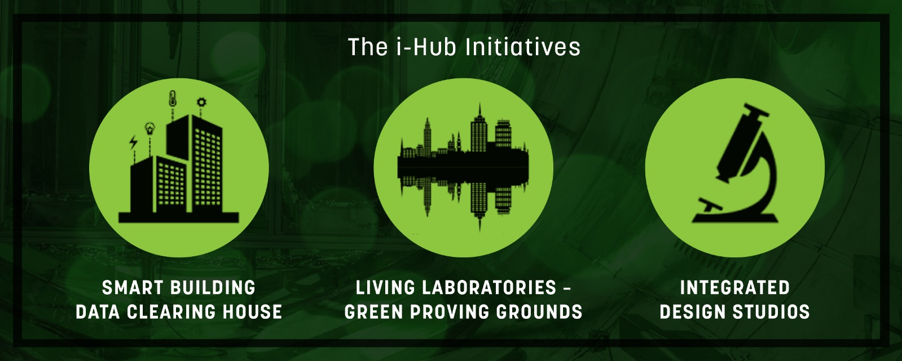

**Project Expression of Interest Form**

This Expression of Interest Form is to facilitate an initial discussion about the alignment of the proposed project with i-Hub objectives and desired outcomes, and to enable i-Hub Activity Leaders to provide more informed guidance on next steps. It is recommended that this form be filled out **after** an initial discussion with an i-Hub Activity Leader, and review of the i-Hub website ([www.ihub.org.au](http://www.ihub.org.au))

|  |
| --- |
| *This form is not an application for funding.* |

i-Hub is open to applications from industry participants who have suitable demonstration projects that require co-funding. Proposals will be considered under one of three activity streams: a Smart Building Data Clearing House; Living Laboratories – Green Proving Grounds; and Integrated Design Studios.

The objectives for the i-Hub Project will be achieved through the following **Outcomes**:

* Improve the control of HVAC&R compared to business as usual by demonstrating the capability within a selection of building types to reduce onsite energy use by at least 25%.
* Reduce peak demand and demand charges as well as increase the hosting capacity of solar through load control combined with onsite renewable energy.
* Increase the value of open data platforms and deliver innovation in the built environment for energy savings.
* Improve developer and building owner decision making capabilities by demonstrating the value of non-monetary benefits of energy productivity measures.
* Identify new technologies that are able to contribute to the decarbonisation of commercial buildings over the next decade.
* Increase available demand response by identifying 100 MW of potential within the broader i-Hub portfolio.
* Change the industry paradigm to make co-design a mainstream approach to deliver lower cost and higher performance buildings.

Any proposals or EOIs i-Hub receives need to be considered from an i-Hub Outcomes perspective.

|  |  |  |
| --- | --- | --- |
|  | **Applicant name** | [Provide the name of the lead organisation] |

|  |  |  |
| --- | --- | --- |
| a. | **Project title** | (20 words maximum) |

|  |  |  |
| --- | --- | --- |
| b. | **Summary of the Project** | |
|  | Provide a brief description of the purpose of the project and how that will be achieved (what are you trying to prove; what does success look like), e.g. | |
| i. | How does the technology / commercial readiness of the product / system get advanced? |
| ii. | If there’s a demonstration component, then where is the host site? |
| iii. | What are other benefits or objectives? |
| What is the indicative overall project cost and how much of that might be requested from i-Hub funding? | |
|  | (100 words maximum) | |

|  |  |
| --- | --- |
| c. | **Project deliverables, outcomes and KPIs** |
|  | Identify the deliverables that will be produced by the project. What are the longer-term outcomes that will be achieved for Australia if the deliverables end up being widely used? List the intended outcomes of your proposed project and the key performance indicators (KPIs) that will be used to track performance. Outline how your proposed project will help i-Hub meet its own outcomes. |
|  | (100 words maximum) |

|  |  |  |
| --- | --- | --- |
| v. | **Project partners** | |
|  | List the key parties participating in this project, their role and their interest in its success. | |
|  | Organisation  Contact details of representative | Organisation background |
| 1 | [Organisation name] | [Describe (i) the organisation; (ii) its role in the project; and (iii) the befits it will get from the project.] |
| [Phone number] |
| [Email] |
| 2 |  |  |
|  |
|  |
| 3 |  |  |
|  |
|  |
| 4 |  |  |
|  |
|  |

|  |  |  |
| --- | --- | --- |
|  | **Project proposed by** | [Name] |
|  |  | [Phone number] |
|  |  | [Email] |
|  | **Date** | [Day] [Month], [Year] |